Tutorial-4

Modules name:Facebook
Test Case ID:Tanvi_002
Environment Information:os:macos(Sequoria 15.5)system : laptop(macbook air)webpage URL:https://www.facebook.com/

Screenshort:
Scenario 1:

Demo login page:Open the facebook
Test Steps:1a
1.Serach facebook application
2.open the mobile screen

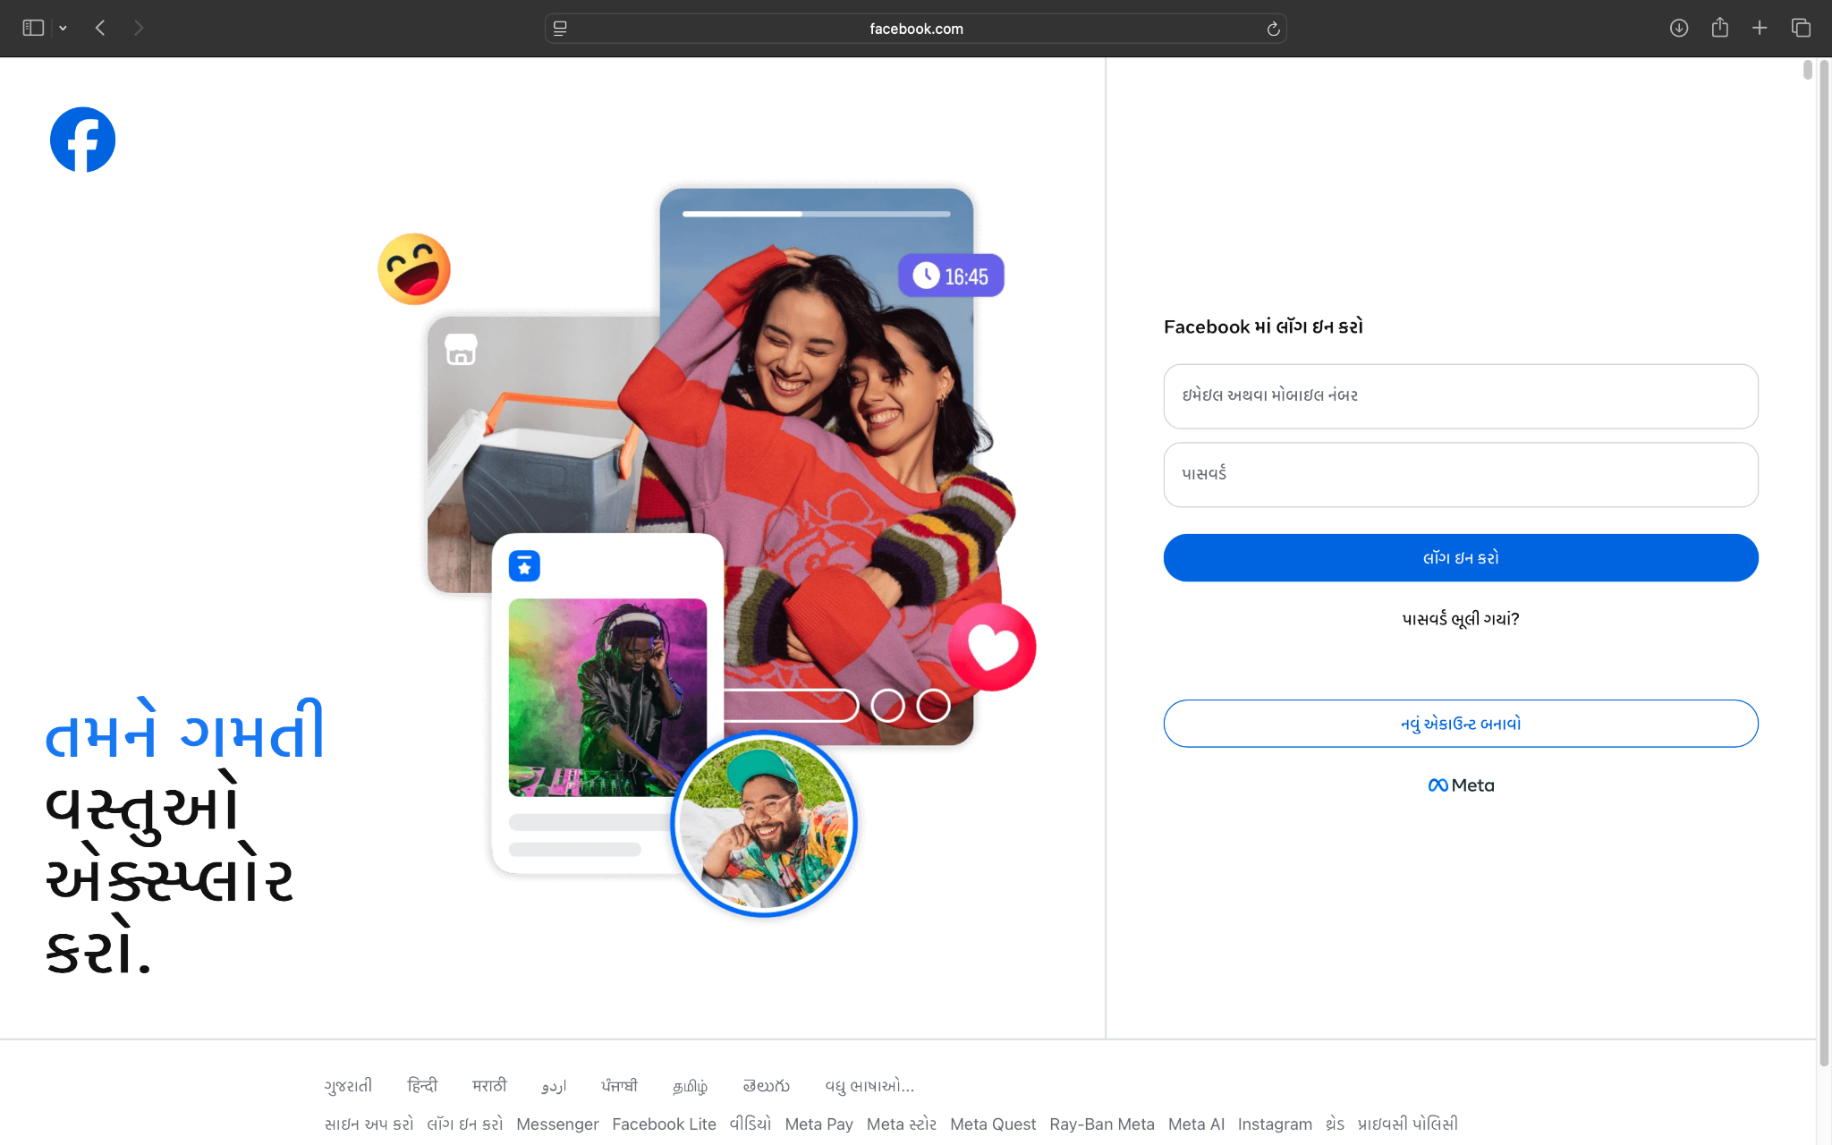

Scenario 1:

Demo login page:Facebook login page
Test Steps:1b
1.Facebook login page open
2.enter email id
3.enter password
4.click on login

Scenario 1:

Demo login page:Facebook login page invalid password
Test Steps:1c
1.Facebook login page open
2.enter email id
3.invalid password
4.click on login

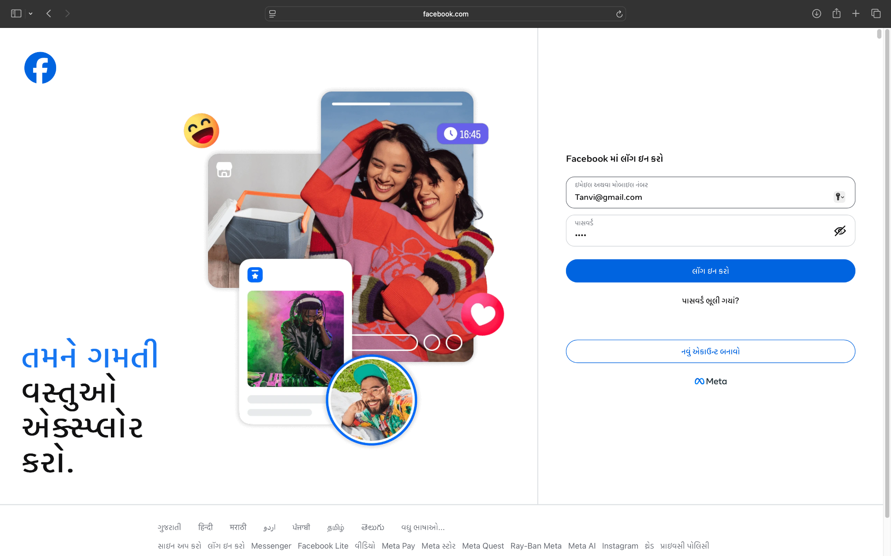

Scenario 1:

Demo login page:Facebook login page invalid email
Test Steps:1b
1.Facebook login page open
2.invalid email id
3.enter password
4.click on login

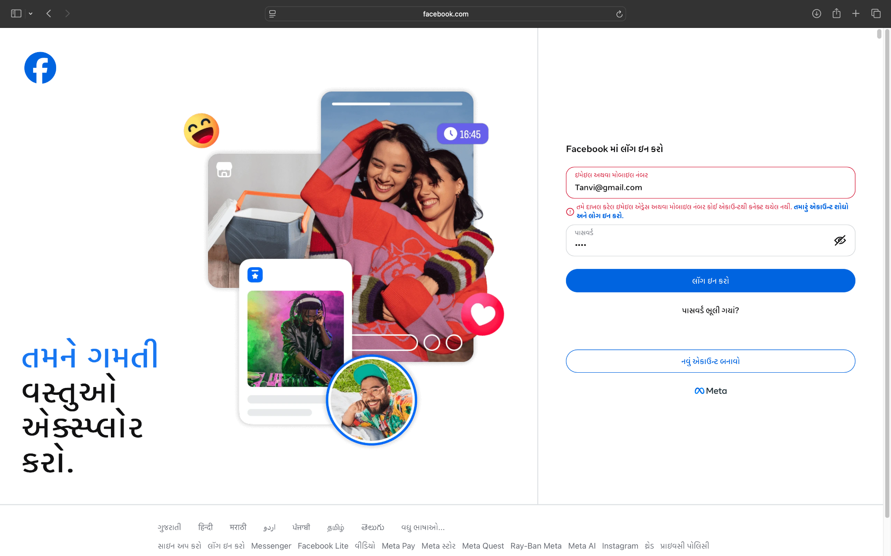

Scenario 1:

Demo login page:Facebook black login page
Test Steps:1d
1.Facebook login page open
2.enter email id
3.enter password
4.click on login

Scenario 1:

Demo login page:Facebook valid login page
Test Steps:1e
1.Facebook login page open
2.enter email id
3.enter password
4.click on login

Scenario 1:

Demo login page:Facebook login page password marking
Test Steps:1f
1.Facebook login page open
2.enter email id
3.enter password
4.click on login

Scenario 1:

Demo login page:Facebook login page forget password
Test Steps:1g
1.Facebook login page open
2.enter email id
3.forgrt password
4.click on login

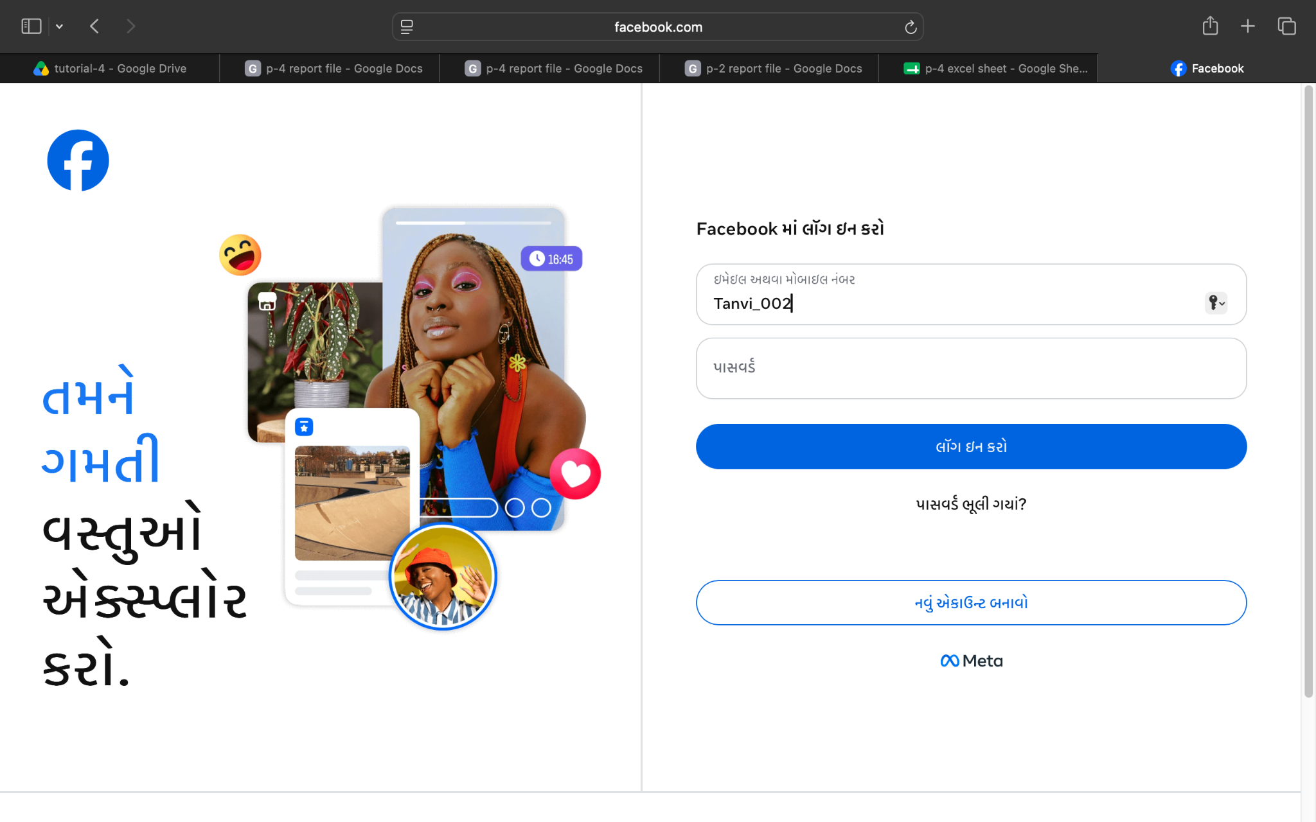

Scenario 1:

Demo login page:Facebook login page open successfully
Test Steps:1h
1.Facebook login page open
2.enter email id
3.enter password
4.click on login
5.open mobile facebook app



Scenario 2:

Demo login page:Facebook logout page
Test Steps:2a
1.Facebook login page open
2.enter email id
3.enter password
4.click on login
5.check the profile successfully open
6.logout page
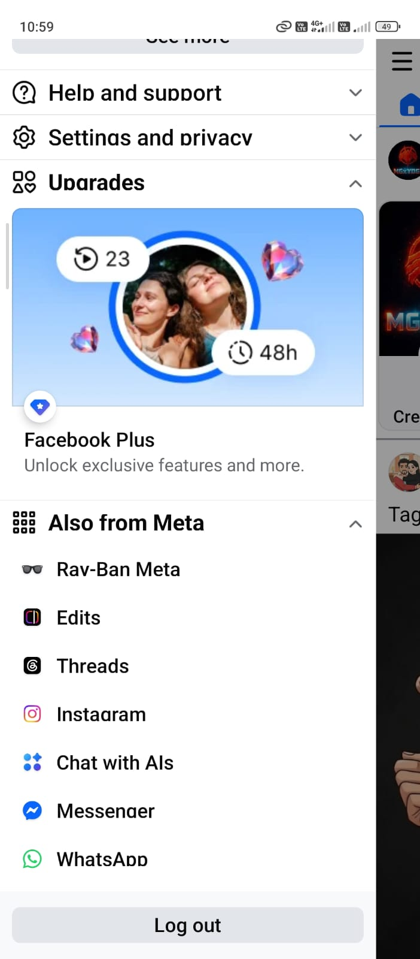

Scenario 2:

Demo login page:Facebook back after logout page
Test Steps:2b
1.Facebook login page open
2.enter email id
3.enter password
4.click on login successfully open
5.logout page
6.back the login page open

Scenario 2:

Demo login page:Facebook login button allignment page
Test Steps:2c
1.Facebook login page open
2.enter email id
3.enter password
4.click on login button allignment
5.check the profile successfully open

Scenario 2:

Demo login page:Facebook login Field spacing page
Test Steps:2d
1.Facebook login page open
2.enter email id
3.enter password
4.click on Field spacing login
5.check the profile successfully open

Scenario 2:

Demo login page:Facebook logout page successfully complete
Test Steps:2e
1.Facebook login page open
2.enter email id
3.enter password
4.click on loginpage
5.check the profile successfully open
6.logout the page

